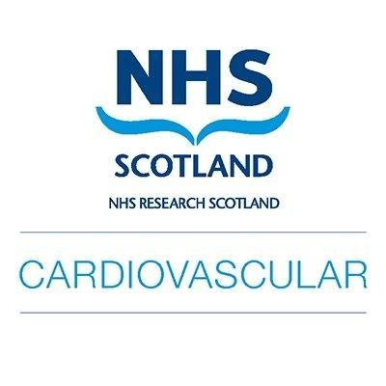

Cardiovascular Research Nurse / AHP Funding ACNAP Congress 2024

National Research Scotland – Cardiovascular Research Network

Application Form

Confidentiality & Data Protection: Please note that your application will be kept confidential and will not be shared.

SECTION ONE – APPLICANT INFORMATION

Title: | First name: | Surname:
Email

Present employment
Place of Work | Post Held | From  (dd/mm/yy) | To  (dd/mm/yy)

SECTION TWO – RESEARCH PROJECT EXPERIENCE

Experience Working in Cardiovascular Research
NB – Projects must be part of the NRS Cardiovascular Portfolio and running within sites in NHS Scotland
Research Project | Role in Project | Outcome of research project

Please describe why you wish to attend ACNAP Congress ?

How to you aim to disseminate learning for attending ACNAP Congress?

SECTION THREE - LETTERS OF SUPPORT

Statement of support from Line manager

Signed (Line Manager ) | Dated
Printed Name, Initials and Position of the Above

Confirmation of study leave from Line Manager

I can confirm I have attained agreement for study leave (maximum of 4 days) to be able to attend Congress.

Signed (Applicant ) | Dated
Printed Name, Initials and Position of the Above

Please return application form to
Mary McAuley – NRS Cardiovascular Research Champion Support Manager
Email – mary.mcauley@gjnh.scot.nhs.uk

Deadline for applications – by 5pm Friday 5th April 2024

